COIT20245 Programming Assignment 3
FINAL PROJECT
(Assessment item 3)

Student ID | 12215318
Student Name | Kshitiz Dhungel

This coversheet must be completed with your submission.
Please check (X) to indicate that you have satisfied these requirements:

☒ This work and my programming submission are my original work and no part of it has been copied from any other student’s work or any other source.
☒ No part of this work or my code has been written for me by any other person/student/software program.
☒ I have taken proper and reasonable care to prevent this work and my code from being copied by another student.
☒ I acknowledge that it is my responsibility to check that the file submitted is readable and complete and that the code submitted can be uploaded in NetBeans and will compile and run correctly.
☒ I understand that plagiarism also includes the act of assisting or allowing another person to plagiarise or to copy my own work.

Description of the Program and Phase Completed
This assignment involves the development of a quiz application where it can load quiz questions from a text file within a code. It is divided into two main parts:
Part 1: Development of quiz questions which are related to different week’s content.
Part 2: Development of console-based quiz application using Apache NetBeans 15. It has two modes, and they include loading quiz questions and answers from a text file and using predefined questions and answers within the code.
This application is divided into several phase or iterative development:
Phase 1: In this phase, classes such as App, Question, and Manager classes were implemented using the UML Diagram and lastly, each question is asked only once using array.
Phase 2: The application was further extended where users were allowed to make multiple attempts at each question. It is specified when constructing Manager Object. Additionally, a loop is iterated until a user gets the correct answer or exceeds the attempts. Secondly, a private method was created to handle the process of asking and getting the response from the user.
Phase 3: Here, a logging function was added to record the user’s performance for each question where Log and Entry classes were introduced to store and manage the logging information. At the end of this phase, a summary of correct answers and total numbers of attempts were displayed.
Phase 4: A save () method was modified to save log information in the text file named report.txt. Furthermore, the information displayed in the console was written to that file saved in the same folder of the application.
Phase 5: In this last phase of the development, a constructor was added to Quiz Class to load the quiz questions from the text file named quiz.txt. The format for the file was provided in appendix 2. The answers and questions were read from the file and used to create Questions object, later added to questions in the Quiz class. Additionally, used file reding techniques to read the file line by line.

Testing
To test the functionality of the program several testing’s is done and test plans were made.

Test Plan
Test Case 1: Basic Question Asking (Phase 1)
Objective: Ensure that the program can ask each question once.
Test Steps:
- Start the quiz application.
- Initialize the quiz with a set of questions.
- Answer each question.
Test Data:
- Quiz questions with multiple-choice, fill-in-the-blank, and true/false formats.
Expected Behavior:
- The program should ask each question exactly once.
- The program should evaluate the user's responses correctly.
- The quiz should end after all questions are asked.
Expected Output/Results:
- The program should display whether each answer is correct or incorrect.
- The result should show the number of correct answers.
Test Case 2: Allow Multiple Attempts (Phase 2)
Objective: Ensure the program allows multiple attempts for each question.
Test Steps:
- Start the quiz application.
- Initialize the quiz with a set of questions.
- Set the number of attempts allowed to 2.
- Answer a question incorrectly and then correctly.
- Answer another question incorrectly twice.
Test Data:
- Quiz questions with multiple-choice, fill-in-the-blank, and true/false formats.
Expected Behavior:
- The program should allow users to retry questions if answered incorrectly.
- It should track the number of attempts and correctness for each question.
- The quiz should end after all questions are asked.
Expected Output/Results:
- The program should display "Incorrect" for an incorrect answer and "Correct" for a correct answer.
- The result should show the number of correct answers and total attempts.

Test Case 3: Add Logging (Phase 3)
Objective: Ensure that the program logs user performance for each question.
Test Steps:
- Start the quiz application.
- Initialize the quiz with a set of questions.
- Set the number of attempts allowed to 2.
- Answer a question incorrectly and then correctly.
- Answer another question incorrectly twice.
- Complete the quiz.
Test Data:
- Quiz questions with multiple-choice, fill-in-the-blank, and true/false formats.
Expected Behavior:
- The program should log user performance for each question.
- It should display a summary of correct answers and total attempts at the end of the quiz.
Expected Output/Results:
- The program should display the correctness and attempts for each question.
- The final summary should show the number of correct answers and total attempts.
Test Case 4: Save Log Data to a File (Phase 4)
Objective: Ensure that the program correctly saves log data to a file.
Test Steps:
- Start the quiz application.
- Initialize the quiz with a set of questions.
- Set the number of attempts allowed to 2.
- Answer a question incorrectly and then correctly.
- Answer another question incorrectly twice.
- Complete the quiz.
Test Data:
- Quiz questions with multiple-choice, fill-in-the-blank, and true/false formats.
Expected Behavior:
- The program should save the log data to a text file named report.txt.
- It should display the summary on the console.
Expected Output/Results:
- The program should save log data in the report.txt file.
- The final summary should show the number of correct answers and total attempts on the console.
Test Case 5: Read Quiz Questions from a Text File (Phase 5)
Objective: Ensure the program can read quiz questions from a text file.
Test Steps:
- Prepare a text file (quiz.txt) with quiz questions in the required format.
- Modify the program to load questions from quiz.txt.
- Start the quiz application.
- Complete the quiz.
Test Data:
- quiz.txt file containing quiz questions in the specified format.
Expected Behavior:
- The program should successfully load quiz questions from the quiz.txt file.
- It should operate as expected with loaded questions.
Expected Output/Results:
- The program should display questions and evaluate user responses as if they were loaded directly.

Test Cases: Data

Test case | Test Input | Expected Output | Actual Output | Pass/Fail
TC: multiple choice question | Selecting incorrect option | Display Incorrect | Displayed Incorrect | Pass
TC: true/false question | Selecting correct answer | Display Correct | Displayed Correct | Pass
TC: fill in the blanks | Selecting correct answer | Display Correct | Displayed Correct | Pass
TC: Multiple attempts for multiple choice questions | Selecting incorrect answer | Displays incorrect in first attempt and, displayed incorrect in second attempt too | Displayed incorrect in first attempt and, displaying incorrect in second attempt | Pass
TC: Multiple attempts for true/false | Selecting incorrect answer | Displays incorrect on first attempt and correct on second attempt | Displayed incorrect in first attempt and, displaying correct in second attempt | Pass
TC: Multiple attempts for fill in the blanks | Selecting correct answer | Displays correct and moves on next question | Displaying Correct | Pass
TC: logging and displaying summary | Answering 4 questions with 3 incorrect and 1 correct | Displays Summary of 1/4 correct, and 7/8 attempts | Summary of 1/4 correct, and 7/8 attempts displayed | Pass
TC: log and displaying individual question results | Answering 4 correct answers | Displays Summary of 4/4 correct, and 6/8 attempts | Summary of 4/4 correct, and 6/8 attempts displayed | Pass
TC: saving the log data | Answering 10 questions with 9 correct and 1 incorrect answer | Displays summary of 9/10 correct, and 12/20 attempts | Summary of 9/10 and 12/20 is displayed | Pass
TC: read quiz questions from a file | Providing a valid text file | Quiz questions loading from the file | Quiz questions are loaded from the file | Pass

Test Output (result of testing)
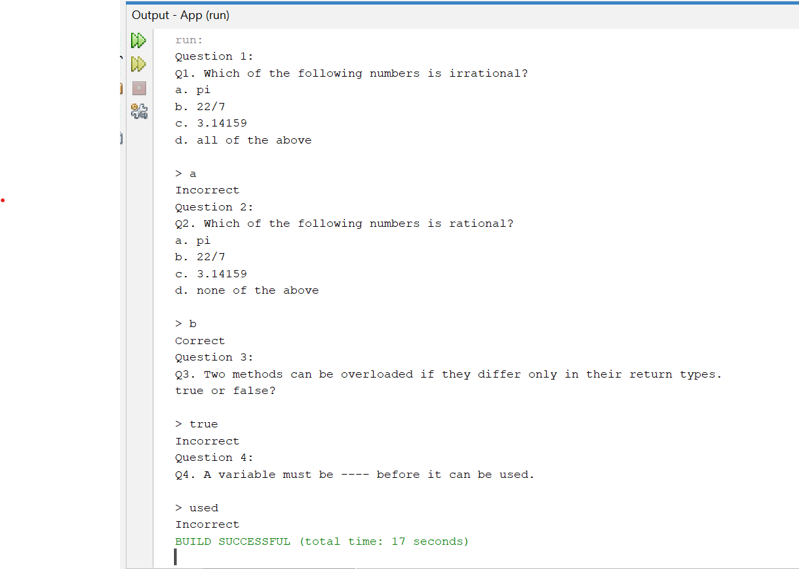

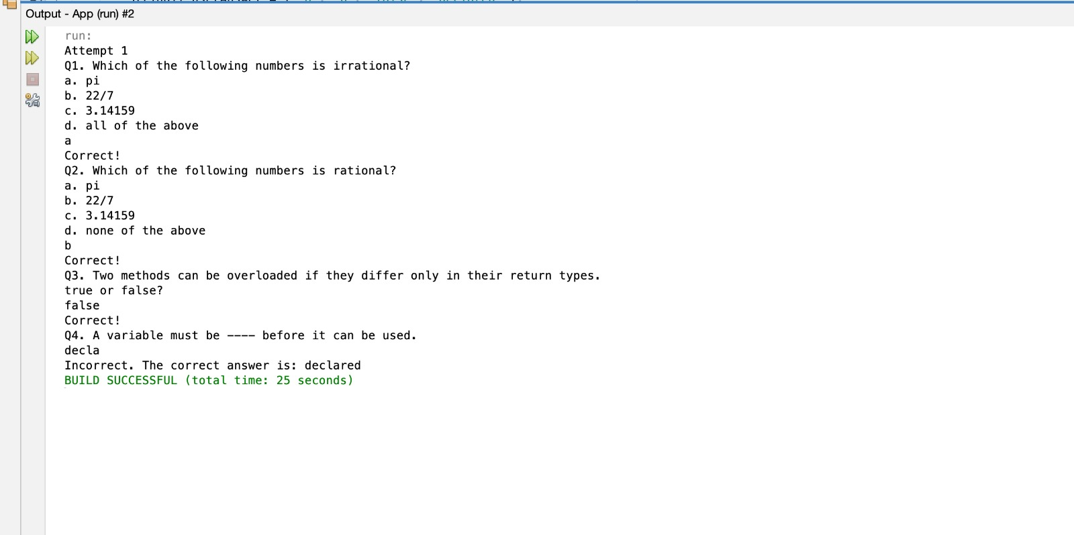
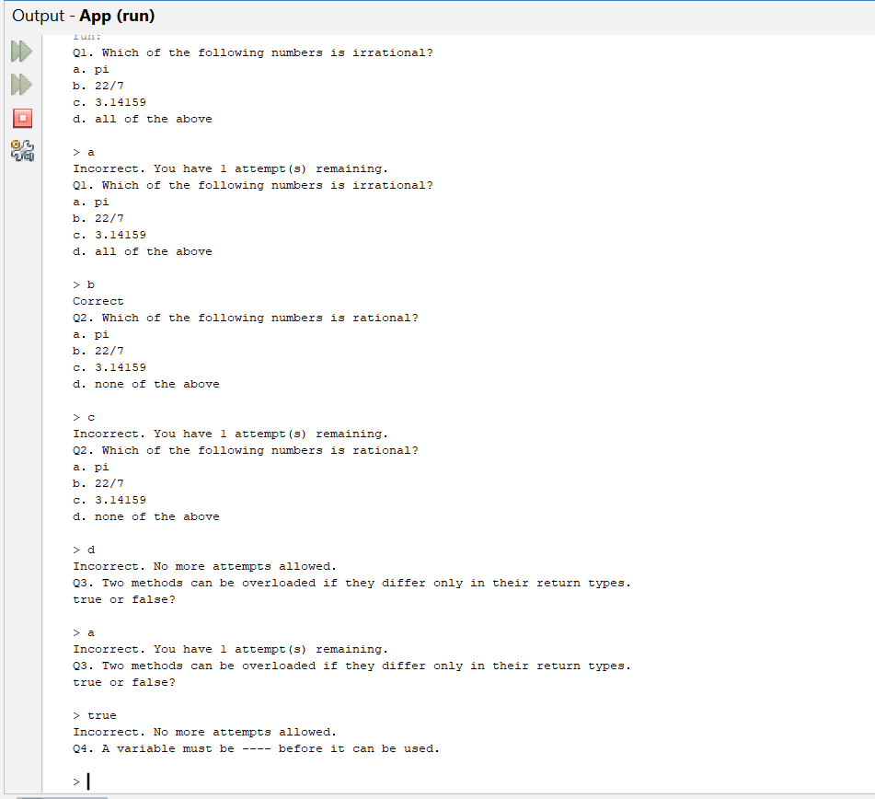
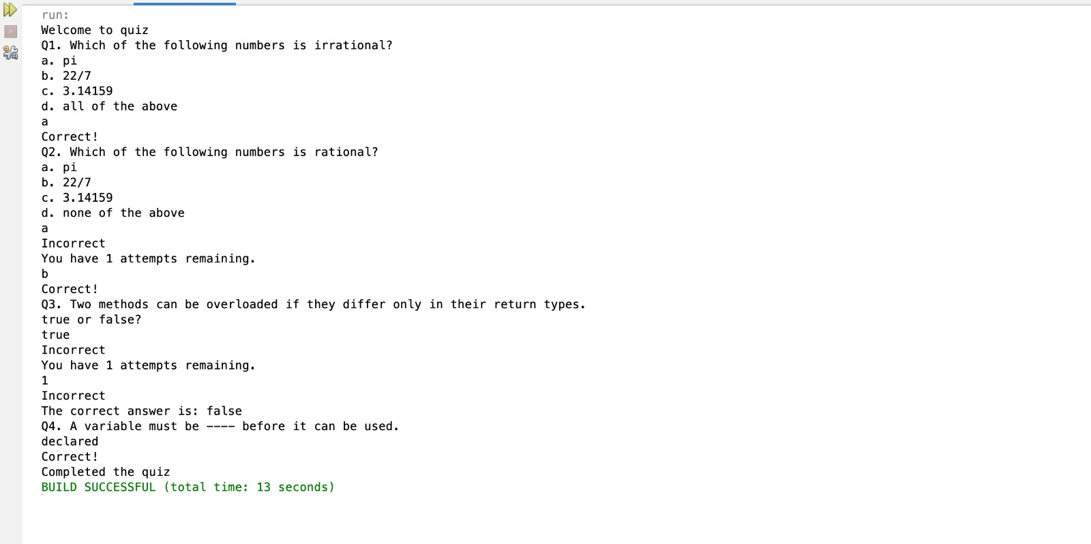
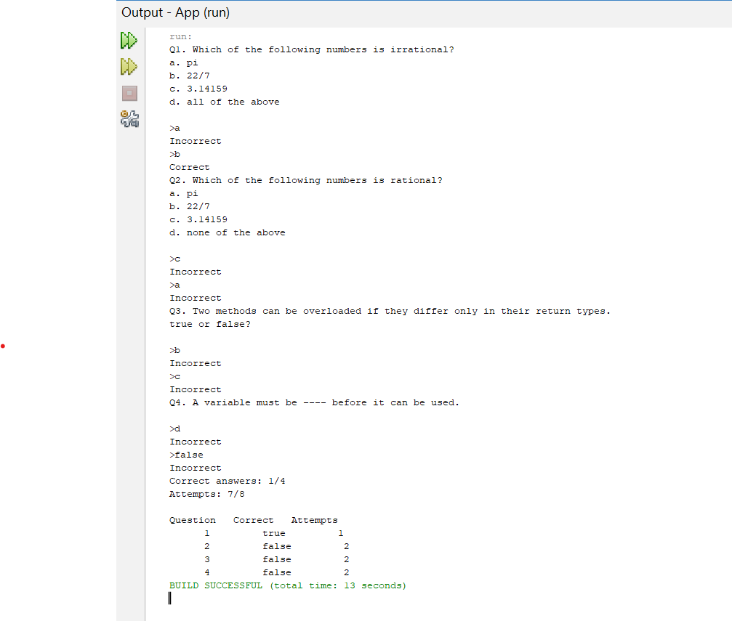
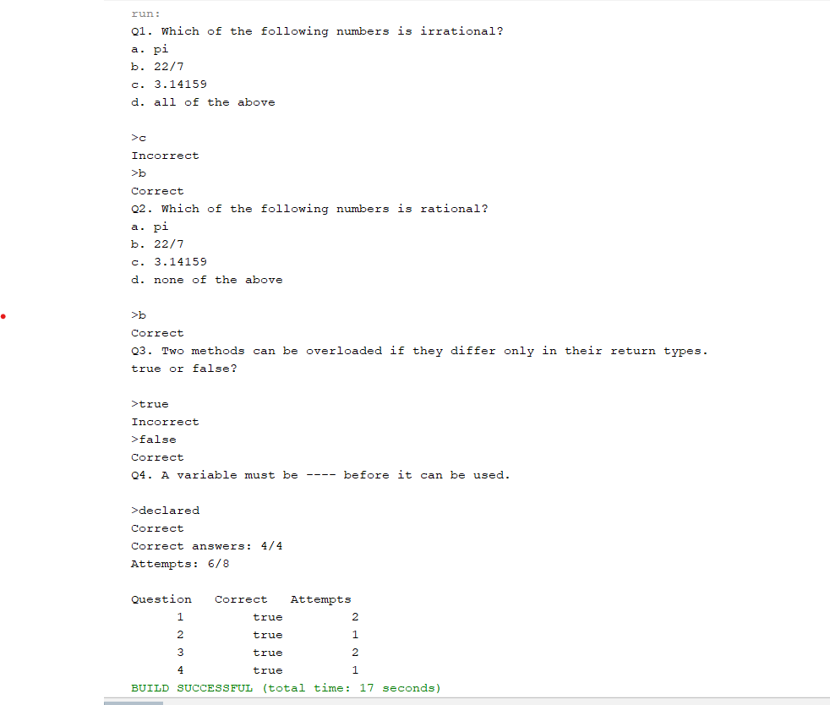

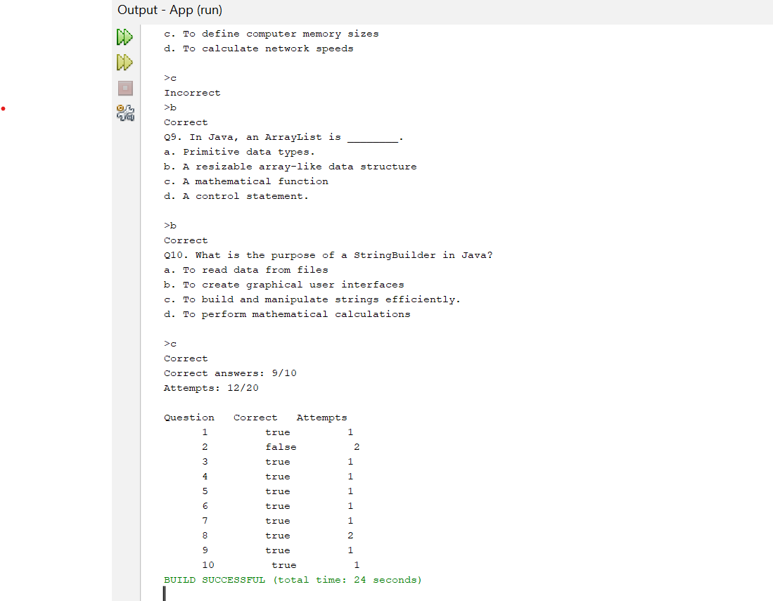

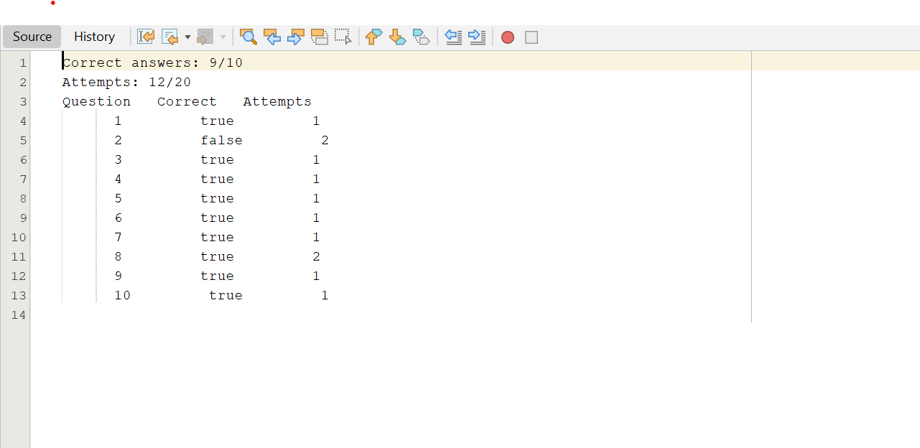

Bugs and Limitations

Bugs
“No known bugs”

Limitations
- File location dependency
- Poorly formatted data which lacks input validation
- No GUI
- Handles limited question types.
- No customization for file paths or quiz settings
Additional Future Work
- Implementing Graphical User Interface to make user friendly.
- Enhancing error handling to provide more error messages to users.
- Adding features for users to review their quiz results.
- Adding a timer feature to track the time taken by user to attempt the quiz.
- Adding multiple language support.

